WEEK 2:

STEGHIDE ASSIGNMENT:

CREATED AN IMAGE A SECRET MESSAGE IN THE DESIRED FOLDER.

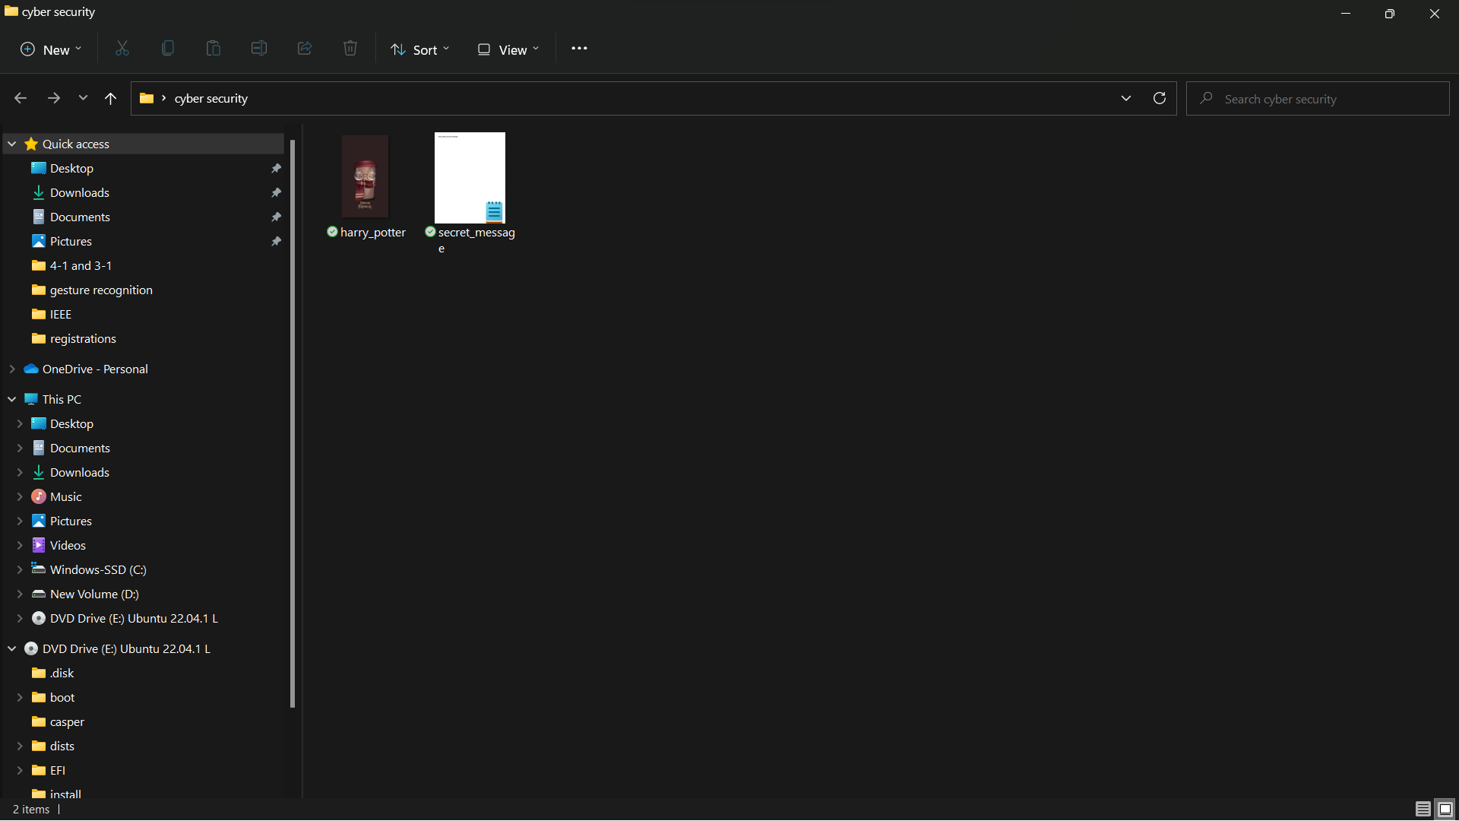

THE BELOW IS THE IMAGE USED

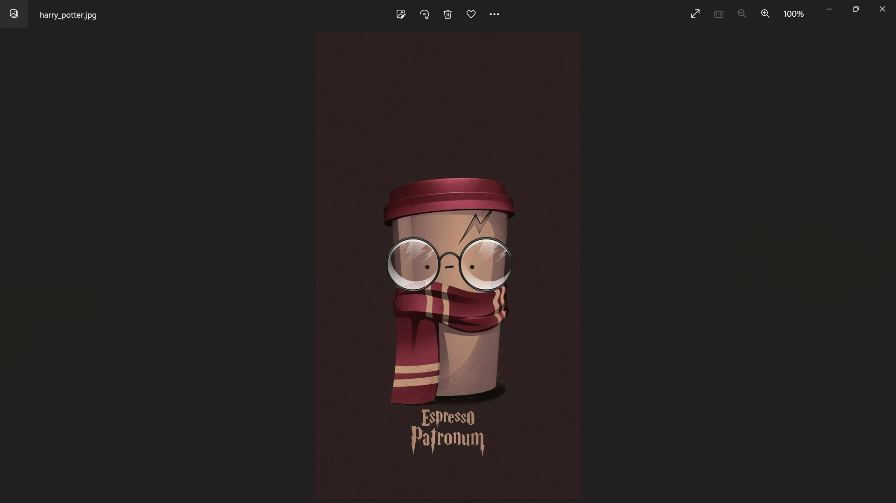

THE BELOW IS THE SECRET MESSAGE USED

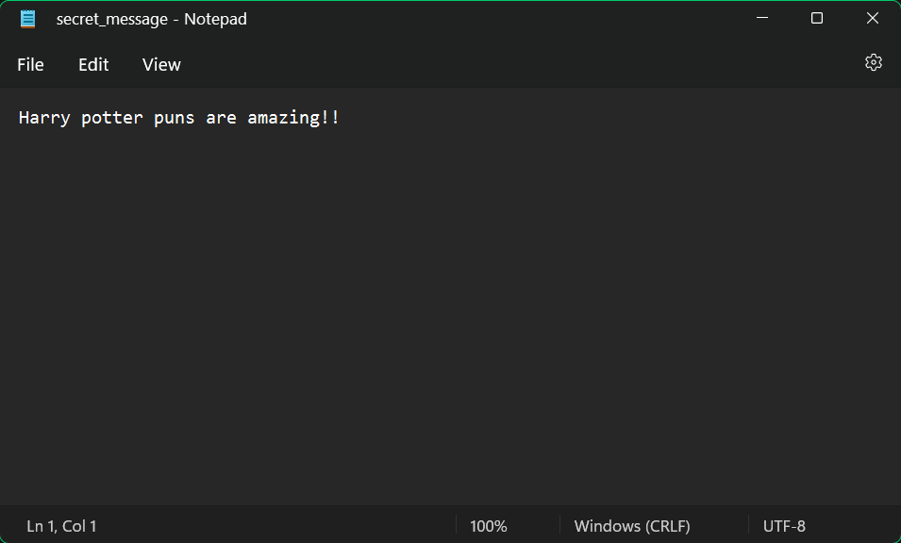

PERFORMING THE STEGNOGRAPHY THROUGH THE COMMAND PROMPT:

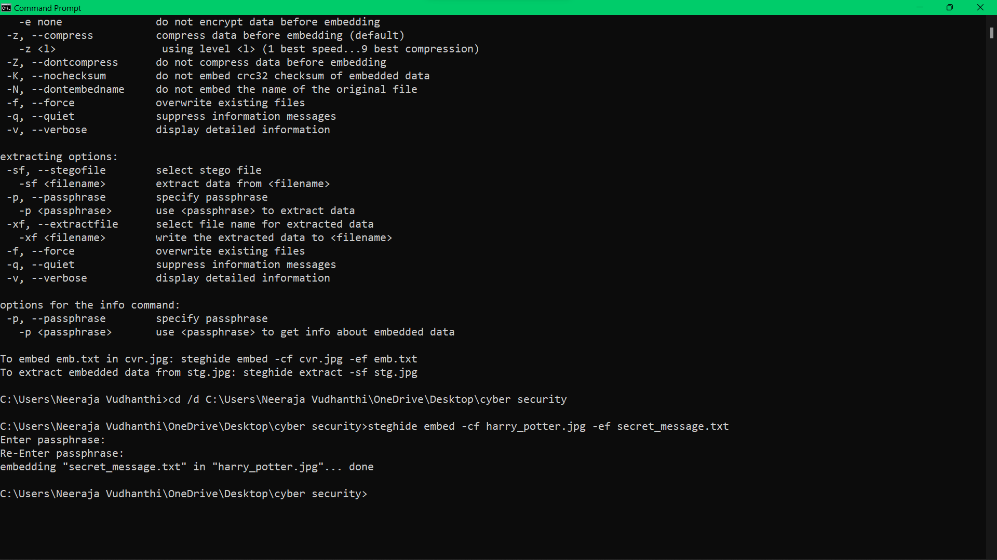

DELETED THE SECRET MESSAGE TO TEST FOR THE DECRYPTION IN THE NEXT STEP:

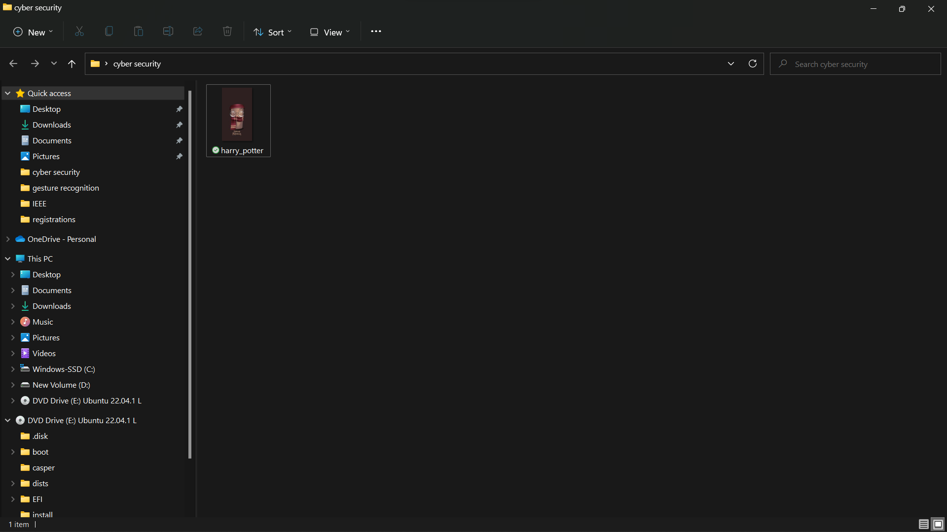

PERFORMING THE DECRYPTION:

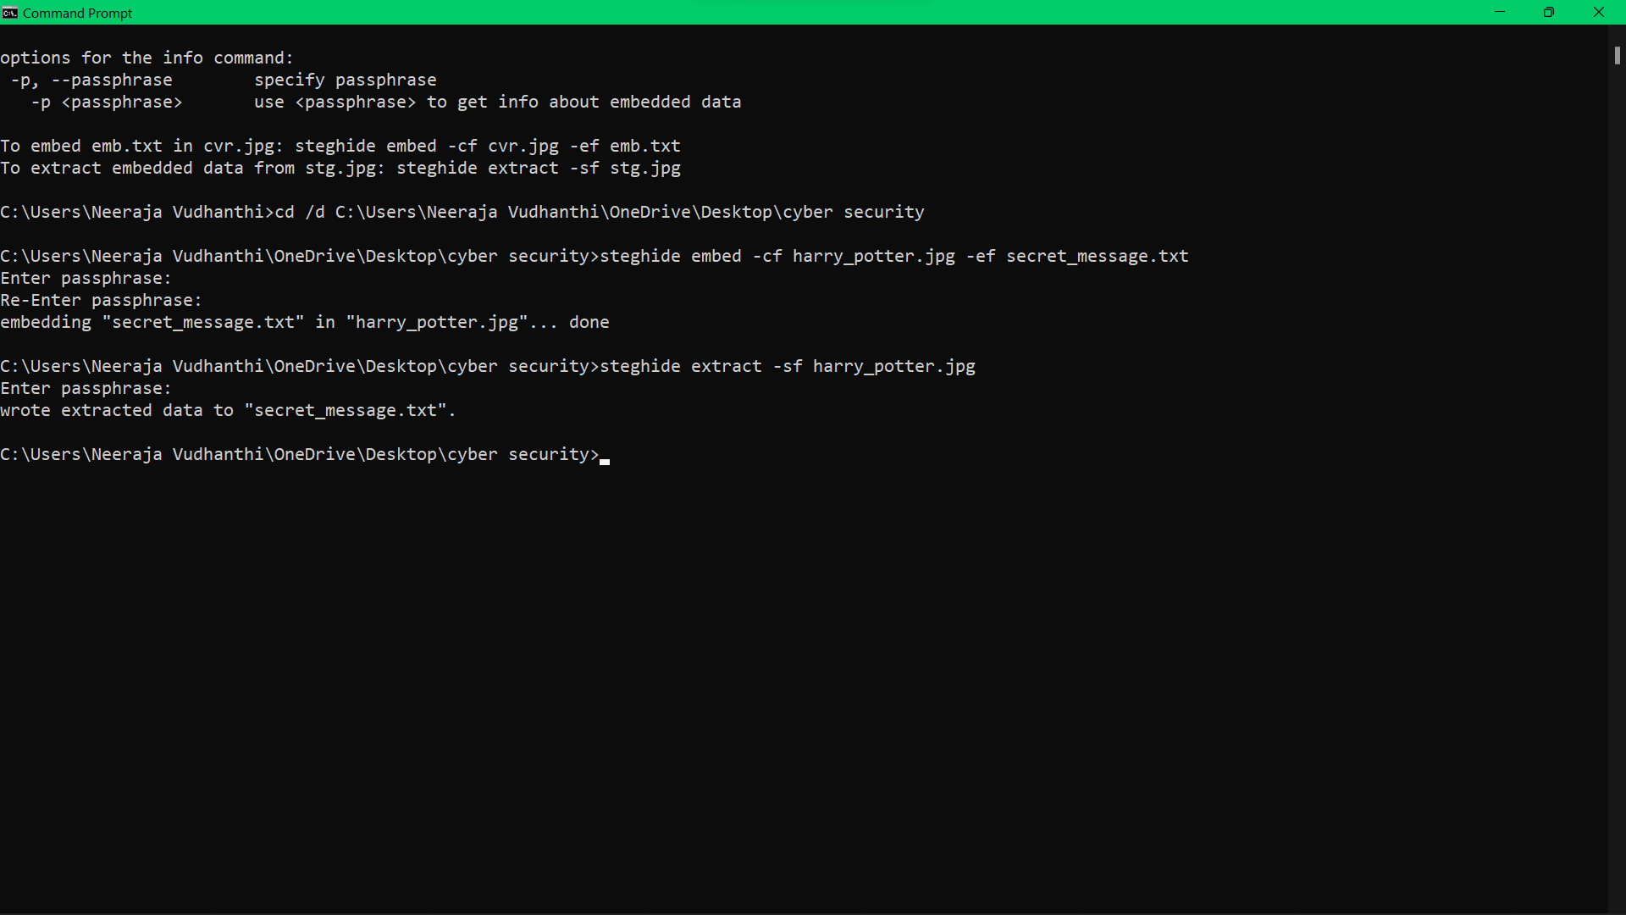

AFTER DECRYPTING THE SECRET MESSAGE REAPPEARS IN THE FILE

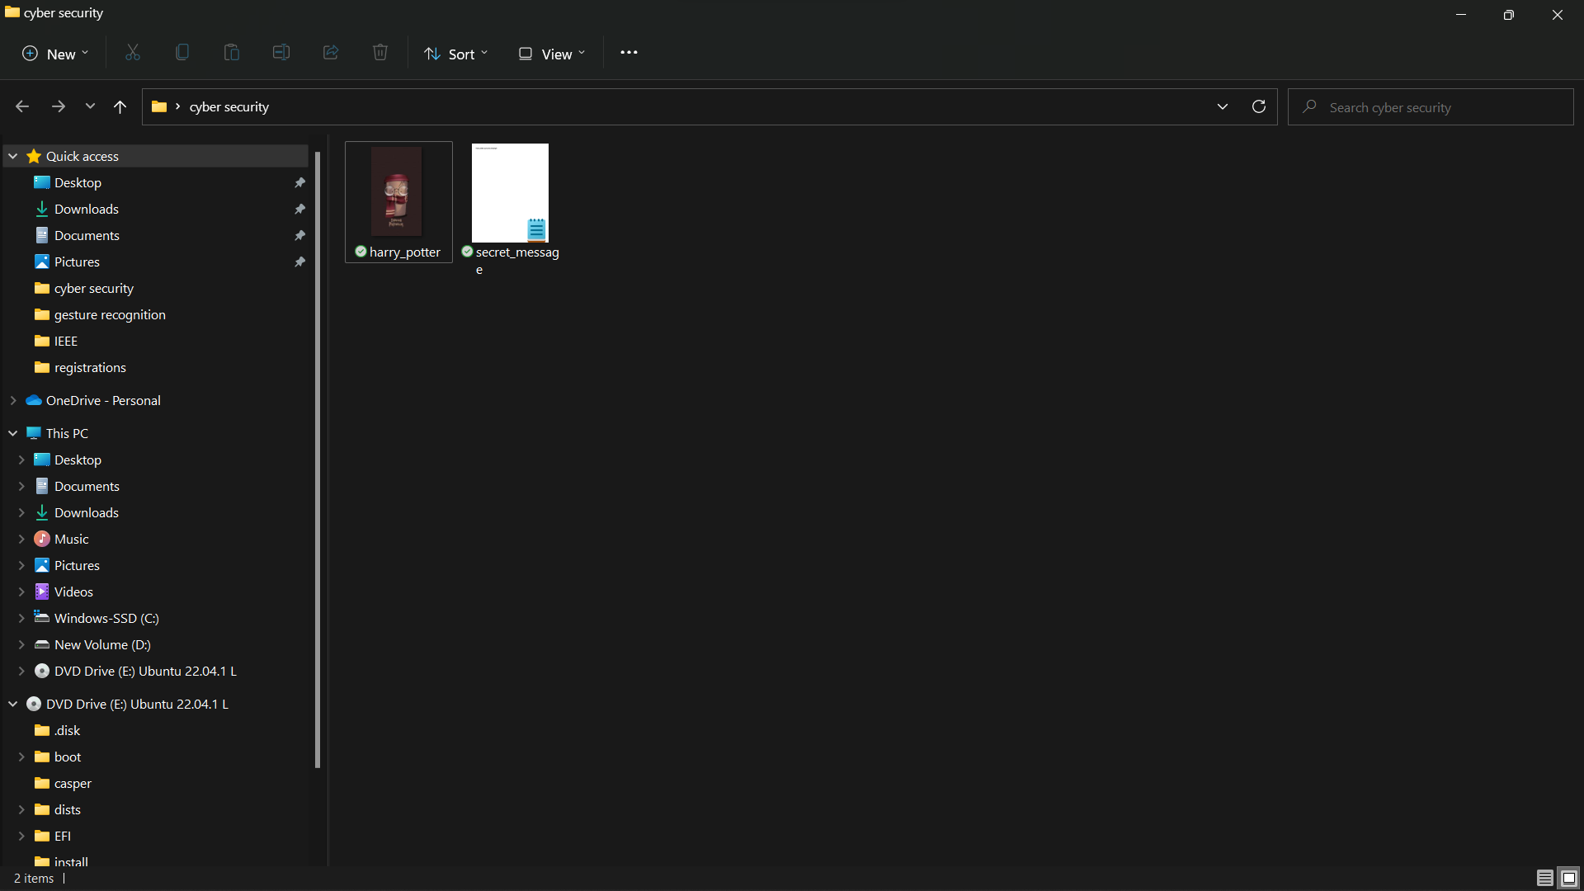

THE BELOW IS THE DECRYPTED MESSAGE:

